- The Bank of England’s Monetary Policy Committee voted 7-2 to hold Bank Rate at 3.75% this week. We stick with our call that policy will remain at its current restrictive level until next year. We think the MPC’s attempts to play down recent falls in energy prices and to reiterate their willingness to act against any emerging second-round effects reflected a desire to prevent financial conditions from loosening too much.
- Andy Burnham comfortably won the Makerfield by-election and will likely launch a leadership challenge soon. We expect Burnham to be successful and to become Prime Minister, with the main uncertainty over whether it will be a coronation or after a leadership contest. But either way, we think the chances of a large front-loaded fiscal loosening in this year’s Budget are low.
Both the monetary and fiscal policy outlooks came under the microscope this week, with the announcement of the Monetary Policy Committee’s June interest rate decision and the results of the Makerfield by-election.
As expected, the Bank of England’s MPC kept Bank Rate at 3.75% this week. The 7-2 vote to hold was widely anticipated, with Megan Greene joining Huw Pill in favouring a 25bp hike, but the closer vote split shouldn’t be seen as a hawkish signal. Most committee members were content to remain in ‘wait and see’ mode until they could make a more informed judgement on the likely strength of indirect and second-round effects of the rise in energy prices since the start of the US-Iran conflict.
Chart 1: Oil and gas futures prices are below what was assumed in all of the MPC’s April scenarios
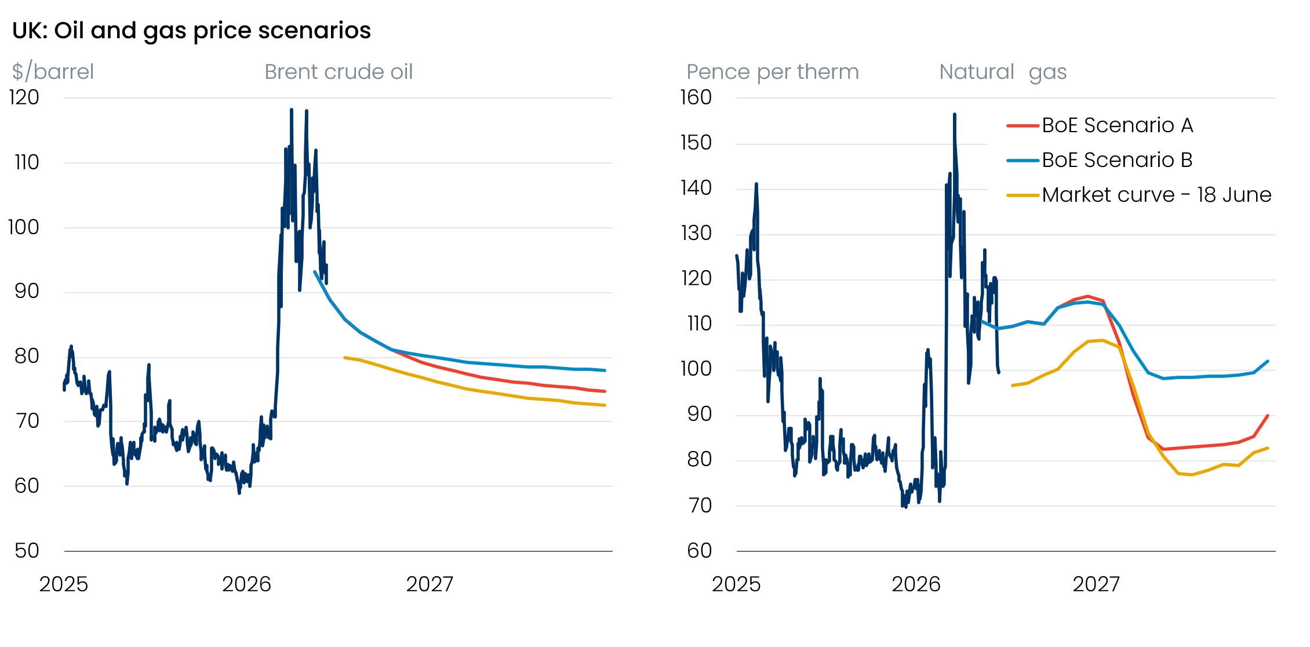
Source: Oxford Economics

April’s Monetary Policy Report had set out three scenarios with varying assumptions for energy prices and second-round effects. But this week’s US-Iran deal has led oil and gas futures prices to drop below even the BoE’s most optimistic scenario for energy prices, Scenario A (Chart 1).
The MPC has linked the scale of second-round effects to the size and persistence of the energy price shock. So the MPC welcomed the retracing in energy prices. But the committee also noted that risks to energy prices remain skewed to the upside, owing to the fragility of the US-Iran deal, the damage to energy supply, and that logistical constraints mean the rebalancing in energy markets will take time to fully feed through to prices.
Most members also expressed greater reassurance that there had been sustained disinflation before the conflict erupted. Downside surprises in this week’s inflation and pay data were part of this story. Most in the no-change camp seem to take the view that the most likely scenario is that a cooling labour market and fragile domestic demand keeps second-round effects contained by weighing on pay growth and margins. So leading indicators on the size of pay deals and firms’ pricing power will remain key to the MPC’s decision making.
We think that attempts to play down the recent fall in energy prices and to reiterate the willingness of the MPC to act against any emerging second-round effects reflect a desire to prevent financial conditions from loosening further. With most of the MPC content to wait and see how developments in energy prices and second-round effects play out, we stick with our call that Bank Rate will remain at its current restrictive level for the rest of this year.
Switching gears, Andy Burnham comfortably won the eagerly awaited Makerfield by-election, securing 54.8% of the vote (Chart 2). The result was more decisive than most polling had suggested and paves the way for Burnham to challenge Keir Starmer for leadership of the Labour party and the role of Prime Minister.
Chart 2: Andy Burnham won a clear majority in Thursday’s Makerfield by-election
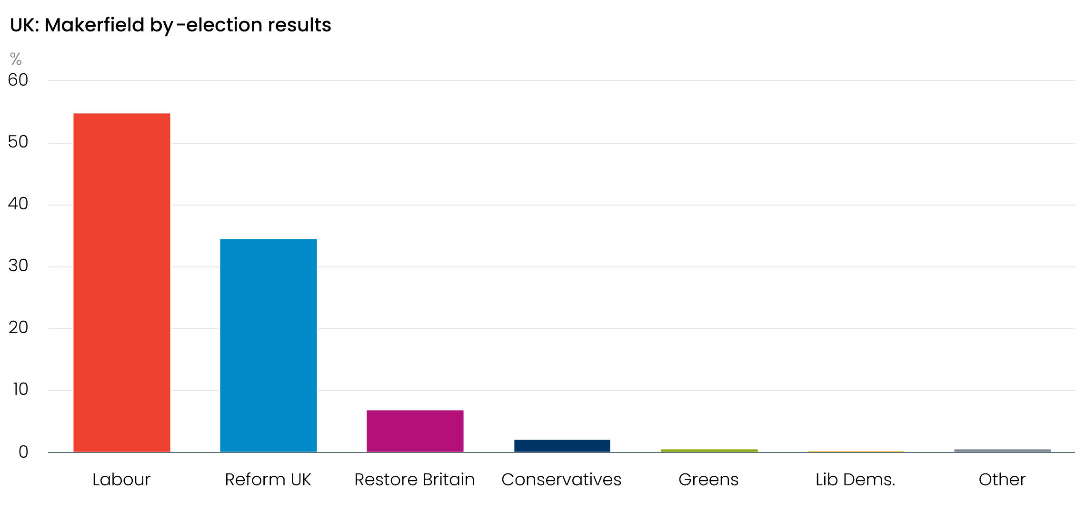
Sources: Wigan Council
We expect Burnham to launch his leadership bid in the coming days, which raises two key questions. First, will Starmer follow through on his commitment to stand in any contest? Second, will any other candidates secure the 81 signatures from Labour MPs necessary to join the contest and set the stage for a lengthier challenge? Whether it be via a coronation or a more protracted contest over the next few months, we expect Burnham to become PM by early autumn.
We will publish a Research Briefing soon, setting out our expectations for Burnham’s policy priorities and analysing the economic implications of his approach. However, our view is that a large front-loaded fiscal loosening at the autumn Budget looks unlikely.
In part, this is because events have moved fast and there’s little to suggest Burnham’s team has a detailed policy package already in the works. Developing that package in time for the autumn Budget will be made even harder if Burnham has to first win a prolonged leadership contest.
However, Burnham will also be operating with limited fiscal space. Some of the existing headroom will likely be eroded by higher gilt yields and market expectations for Bank Rate. And given some nervousness in markets about Burnham’s approach, we suspect the new leadership will err on the side of caution and opt against tweaking the fiscal rules in the near-term. As a result, any changes to the government’s current consolidation plans are likely to be announced after this year’s Budget.

The week ahead
The only economic release of note next week is June’s flash S&P Global survey. May’s composite PMI reported stalling private sector activity, due to weaker momentum in the services sector. But the survey’s results tend to be heavily affected by swings in sentiment related to the news flow. We think the US-Iran ceasefire deal and related sharp fall in energy prices this week will boost corporate sentiment, particularly in sectors that are relatively energy-intensive and those that have seen significant margin pressures in recent months. Therefore, we expect the flash S&P Global survey will show the composite PMI rebounding to 51.9 in June.
Table 1: Week ahead calendar
Date | Events | Period | Measure | Unit | Previous | Forecast
Jun 23 | S&P Global manufacturing | Jun | PMI | % bal | 53.9 | 54.1
Jun 23 | S&P Global services | Jun | PMI | % bal | 49.3 | 51.5
Jun 23 | S&P Global composite | Jun | PMI | % bal | 49.7 | 51.9
Source: Oxford Economics

Key forecasts
Table 2: UK forecast overview
(ANNUAL PERCENTAGE CHANGES UNLESS SPECIFIED)
 | 2024 | 2025 | 2026 | 2027 | 2028 | 2029
GDP | 1.0 | 1.4 | 0.9 | 0.8 | 1.8 | 1.7
Private consumption | -0.1 | 0.8 | 0.7 | 0.6 | 1.5 | 1.8
Fixed investment | 1.7 | 4.3 | 0.3 | 1.5 | 2.5 | 2.1
Government consumption | 2.9 | 1.6 | 1.3 | 1.6 | 1.4 | 1.2
Consumer prices | 2.5 | 3.4 | 3.1 | 2.5 | 1.9 | 2.0
Unemployment rate (%) | 4.3 | 4.9 | 5.4 | 5.6 | 5.1 | 4.7
Current a/c balance (% of GDP) | -3.0 | -2.4 | -4.1 | -3.3 | -2.8 | -2.6
Government balance (% of GDP) | 5.2 | 5.0 | 3.6 | 3.6 | 2.9 | 2.6
Central bank policy rate (%, EOP) | 4.75 | 3.75 | 3.75 | 3.50 | 3.00 | 2.75
10yr govt. bond yield (%, EOP) | 4.57 | 4.47 | 4.97 | 4.43 | 3.82 | 3.57
Exchange rate (US$ per £, EOP) | 1.25 | 1.35 | 1.30 | 1.30 | 1.30 | 1.30
Exchange rate (euro per £, EOP) | 1.21 | 1.15 | 1.12 | 1.10 | 1.10 | 1.10
Source: Oxford Economics
Table 3: Quarterly forecasts for the UK
 | 2026 |  |  |  | 2027
 | Q1 | Q2 | Q3 | Q4 | Q1 | Q2 | Q3 | Q4
GDP (% year) | 1.1 | 1.0 | 0.7 | 0.6 | 0.3 | 0.5 | 1.0 | 1.3
CPI inflation (% year) | 3.1 | 2.8 | 3.2 | 3.4 | 3.2 | 2.7 | 2.2 | 1.9
Bank Rate (%, EOP) | 3.75 | 3.75 | 3.75 | 3.75 | 3.75 | 3.75 | 3.75 | 3.50
10yr gilt yield (%, EOP) | 4.88 | 4.90 | 4.99 | 4.97 | 4.92 | 4.79 | 4.62 | 4.43
US$ per £ (EOP) | 1.32 | 1.34 | 1.32 | 1.30 | 1.30 | 1.30 | 1.30 | 1.30
Euro per £ (EOP) | 1.14 | 1.16 | 1.14 | 1.12 | 1.11 | 1.10 | 1.10 | 1.10
Source: Oxford Economics

Latest Country Economic Forecast:
Jun 19, 2026

Recent publications

Data Insights
Retail sales bounced back in May
Government borrowing already off track
Labour market remains loose
Another downside surprise for inflation
Strong start to the year begins to fade

Research Briefings
The MPC remains firmly in wait-and-see mode
MPC preview – Another hold, but the door will be kept open to hikes
Is a more optimistic view on recent productivity trends justified?
Debt predicament – structural weakness and a credibility deficit
Are European countries with high AI use seeing higher productivity growth?

Contacts

Oxford Economics' UK team
- Andrew Goodwin – Chief UK Economist – agoodwin@oxfordeconomics.com
- Edward Allenby - Senior UK Economist - eallenby@oxfordeconomics.com

